The Habit of Combat: What Fencers Wore

By David Stamper

Introduction

This paper will examine the types of clothes worn by figures in fencing manuals from the early 15th c. to the early 17th c. The intent of this paper is give fencers in the Society for Creative Anachronism (SCA) an idea of what their historic counterparts wore when practising the act of combat. This essay is not intended to dictate what people should wear on the fencing list but provide some historical inspiration, and give an idea of what was worn in period.

In addition to the extant fencing manuals, the paper will review material from contemporary books, art works and accounts of duels. There will also be a focus on the main areas where fencing manuals were published, Italy and Germany.

From the early 15th c. onwards and perhaps earlier, masters of fence began to record on paper descriptions of their techniques for the benefit of their students and later for wider publication. These texts often included illustrative figures that ranged from the crude to the exquisitely elaborate. The illustrations found in fencing manuals offer a window on the various styles and types of clothing worn by people during combat.

One thing that must be noted is that many of the figures in some manuals, like Camillo Agrippa’s *Trattato di scientiad’arme* and Ridolfo Capo Ferro’s *Gran simulacro*, are depicted as nude or minimally dressed. It is highly unlikely that people fenced in the nude during the time period under examination in this paper; at least the author has found no contemporary accounts mentioning this. The nude figure is very much in keeping with the traditions of Renaissance art, harkening to classical depictions of the human form. Nude figures are also useful to illustrate body position as it is not obscured by clothing. The effect of an attack is also more readily apparent, including the point of entry and exit of the blade.

In addition to the study of the classical form, formal human anatomical study increased during the Renaissance. Books like Andreas Vesalius’ *De humani corporis fabrica* examined the human form, inside and out[1]. Such studies were very useful to the artist who wanted to accurately portray body positions and the effects of wounds.

Manuals with only nude figures, like Fabris’ *Scienza e practicad’arme*, or lacking illustrations, like Giovanni dall’Agocchie’s *Dell’arte di scrimia*(1574), will only be considered in passing.

Unfortunately the depictions of figures in fencing manuals are almost always male, and descriptions of women involved in the study of swordplay are rare. Thus this paper will not be able to examine in any great depth what women may have worn while fencing, but this may be an interesting topic for further research.

As noted above, some of the illustrations in the fencing manuals are quite crude, which can complicate identifying the different parts of an outfit, or where one layer ends and another begins. Where possible, comparisons have been made to contemporary art and even extant clothing.

Italy

Italy has a rich tradition of Renaissance martial arts and much of this tradition survives in the form of extant fencing manuals. Some of the earliest known manuals on fencing come from the Italian peninsula, beginning with Fiore de Liberi’s *Flos Dulletorum/Fior de Battaglia/The Flower of Battle* written around 1410. In northern Italy a series of printed manuals were published based on the teachings of Lippo Bartolomeo Dardi, which have come to be known as the Dardi or Bolognese Tradition. The works of Achille Marozzo, Antonio Maciolino, Giovanni dall’Agocchie and Angelo Viggiani are considered part of this tradition. Other notable writers on the art of defence in Italy include the Spaniard Pietro Monte, the mathematician Camillo Agrippa, Giacomo di Grassi, Salvatore Fabris, Ridolfo Capoferro and Nicoletto Giganti.

An important thing to remember about Italy is that during the 15th and early 16th c. the region was the scene for various wars between individual city states and later as the venue for a titanic struggle between two of the most powerful states of the time period, the Hapsburg Empire and the Kingdom of France. The various Italian Wars would see an influx of thousands of mercenary soldiers from all over Eastern and Western Europe, including such exotic places as England and Hungary. The wars in Italy between the Valois French and the Hapsburg Empire began in 1494, and a defining peace would not be reached until 1559.[2] In the interim, armies from France, Germany, Spain and native Italian states, also employing mercenary soldiers, would use Italy as their battleground. Italian fashion would be influenced by, and in turn influence that of other states, including traditions in martial arts.

Italy is where the Renaissance began and first flourished. The ideas of the Renaissance spread all over Europe, through what one German scholar, heavily influenced by Italian humanism, described in the late 15th c. as “the commonwealth of letters”.[3] Building on classical knowledge, it affected everything from poetry, painting, sculpture, and literature to the more practical areas of mathematics, engineering and the military arts all over Western Europe. Italian schools of defence influenced those of other European states, even exporting manuals, like that written by Giacomo di Grassi, and teachers, like Vincentio Saviolo, to England.

The revival of the ideas from the classical past influenced the development of Italian fencing. A number of the fencing manuals published in the 16th c. and early 17th c. contained very naturalistic figures and employed Renaissance artistic concepts such as the use of perspective. As noted above, many of the figures portrayed were nudes. Agrippa, who was an engineer, architect and mathematician[4], included concepts from the study of geometry in his manual. His *Trattato di scientia d’arme* is one of the first systematic approaches to the art of fencing, employing multiple figures to represent different phases of movement. He was also first to label his diagrams with letters that referred to the text.[5] Unfortunately not all manuals took this approach. “Most authors, and the artists who worked for them, concentrated on a more simple figurative technique, and their books are filled with pairs of fencers or wrestlers still battling it out as in days of yore, prodding holes in each other, breaking arms and backs, throttling, gouging, stabbing and cutting.”[6] Many of these manuals, like those of Giganti and Capo Ferro, maintained the concept of the classical nude figure.

The Italian fencing manuals cover a variety of forms of combat including the two handed sword, pole arms of various types, dagger, spear, as well as unarmed combat. Several manuals deal with the use of the single handed sword often in conjunction with bucklers, round shields, daggers, cloaks and sometimes another full sword.

Germany

Like Italy, the area of Western Europe we now know as Germany produced a rich tradition of martial arts. As in Italy, many of these traditions were recorded in the form of fencing manuals. Though written before the time period covered by this paper, the Walpurgis *Fechtbuch*, also known by its manuscript number I.33 c. 1320, is possibly the oldest extant manual on fencing[7].

A thread that runs through German fencing manuals is composed of the teachings of the 14th c. master Johannes Liechtenauer. His poem of rhyming couplets, known as an epitome, or *zettle*[8] in German on the use of the two-handed sword forms the basis of a whole school of German fencing that is often referred to as the Liechtenauer Tradition.

The early history of fencing manuals, or *Fechtbuch* as they are known in Germany, is somewhat murky. In some cases it is difficult to even identify when a particular author lived. Also, a number of the *fechtbuch* are compilations of previous works and there are several different editions of some works often with different illustrations. For example, there are numerous editions of a book called *Gladiatoria* as well as several editions of a work by Hans Talhoffer, the first of which is c. 1443[9]. Copies of his manuscript were produced up until the 1820s. Dozens of these books were created in manuscript form, all written and illustrated by hand, and it wasn’t until the mid-16th c. that we see printed versions like Christian Egenolff’s *Der Altenn Fechteran fenglichekunst* c. 1558[10] and later Joachim Meyer’s *Grundtliche Beschreibung der Kunst des Fechtens*of 1570. Some early 17th c. German *fechtbuchs* do include nude figures, like the Schoffer Fechtbuch c. 1620.

Many of these *fechtbuch* deal with wrestling and the use of the two handed sword, while others explored the use of weapons such as polearms, daggers, the *grosse messer* (Big Knife), quarterstaff and the dussack, which was a wooden or leather practice version of the *messer*. Numerous treaties cover the use of the single sword and its accompaniments like the dagger, buckler and cloak. As will be seen some manuals contained sections on judicial dueling with its unique clothing and weapons.

The Fifteenth Century

One would expect the fashions portrayed in fencing manuals, at least the ones where the figures are actually clothed, to conform to the fashions of the day. This is largely but not universally true, something that can be said of both Italian and German manuals, at least those published in the early part of the 15th c.

As noted earlier one of the earliest fencing manuals we are aware of from Italy is Fiore’s *Flos Dulletorum/Fior de Battaglia/The Flower of Battle* which comes down to us in the form of four surviving manuscript copies, the Morgan Library’s *MS M.383*, The Getty Museum’s *MS Ludwig XV 13*, *The Pisani-Dossi MS*, and the *MSS Latin 11269*[11] also known as the *Florius de Arte Luctandi[12].* These manuals portray various forms of martial arts including: wrestling, dagger fighting, and use of the two-handed sword, the pole-axe, and various other weapons. Most figures are depicted in clothing but some are also depicted in the full armour of the time.

The outfits worn by the clothed figures in the Pisani-Dossi (Figure 1), Morgan (Figure 2), and Getty manuals are quite similar, consisting of a close-fitting skirted garment covering the torso and arms over a pair of hose, which extend to cover the whole leg including the foot. The torso garment is belted at the waist, and is closed down the front, sometimes with buttons. The skirts extend to cover the upper thighs and in some cases are split up to the top of the thighs on both sides. Many of the skirts edgings are depicted as dagged in various ways including half circles, triangles and oak leaves. In many ways the garment resembles a close fitting tunic or possibly a *cotehardie*, but the puffed up shape of the chest implies that it may be padded, possibly being meant to be worn under armour in the form of an arming doublet also known as a *pourpoint*. This would make sense in that the manuals are intended for knightly training, and as noted earlier some of the figures wear armour. Also, the pourpoint had begun to enter civilian use, usually worn under a loose fitting garment called a *houppelande* or a gown[13].

The clothing depicted in MSS Latin 11269 (Figure 3), which is in colour, is somewhat more complicated. The doublets sometimes possess elaborate sleeves which extend down the figure’s back and are often themselves dagged, ending in tassels. There also seem to be representations of surcoats, a garment often worn over a doublet, resembling a short poncho open at the sides. The front was usually belted down with the back left free to hang down the back like a cape. Many back views seem to show the garment cut into ribbon-like strips, some dagged, some are edged in small dots that may represent buttons. Surcoats were also commonly worn over armour as a sort of dust protector and to keep direct sunlight off the metal. An example can be seen in the brass of the English Knight Sir William Bagot, who died in 1407.[14]

|  |  |  |
| --- | --- | --- |
| Figure 1 | Figure 2 | Figure 3 |

Some figures in all four manuals wear what appears to be a single garter at the knee of one leg of the hose. Also, the images from MSS Latin 11269 indicate that some of the hose is particoloured, each leg being a different colour. There does not seem to be any indications of shoes or boots on the feet of any of the figures.

A number of different head coverings are seen in the various manuscripts. There are depictions of what appear to be simple arming caps, hoods that cover the head and upper shoulders; and narrow peaked caps remarkably like the stereotypical Robin Hood hat. A number of figures are shown wearing crowns. The MSS Latin 11269 manuscript shows a number of more elaborate hats including: bag shaped hats; turban like head wraps; caps with turned up edges; pointed hats with brims; long toque like hats and many more.

It is interesting that the short, tight fitting clothing depicted in the various manuscripts is in contrast to the civilian fashion of the day, which tended to looser, longer clothing like the aforementioned houppelandes, known in Italy as *cioppa*; gowns, and the *dogalina* as seen in Cesare Vecellio’s 16th c. work on costume *Habiti antichi et moderni di Diverse Parti del Mondo[15]*. The influence of the often elaborately dagged houppelandes can be seen on the surcoats depicted in MSS Latin 11269, especially in the dagged sleeves and ribboned backs which many of them possess.

The men depicted are training in the knightly arts of combat and the garments they are wearing reflect this. Voluminous garments, with their yards of material, would hinder the actions of the fighting man and long clothing would be a tripping hazard. It would also be difficult to wear armour over a garment like a *cioppa* or *dogalina*. The garments worn in the manuals actually foreshadow later Italian fashion, with its tight-fitting doublets and surcoats. A military garment, the pourpoint, entered civilian use as a under layer which eventually became an outer layer.

The German fencing manual commonly referred to as the *Codex Wallerstein* is interesting as it provides us with a comparison of clothing from the beginning of the 15th c. and towards its end. Two of the manuals included in it are dated from the 1470’s, but the third is dated to c. 1400. The 1400 manual shows fighting with the two handed sword both armoured and unarmoured, armoured dagger fighting, wrestling, and armoured spear fighting. Some combatants also fight with large shields which have projecting spikes and hooks. Two images from the 1400 manual are provided below as figures 4 and 5. The outfits worn by the various fencers and wrestlers depicted are comparable to those seen in Fiore (Figure 1 and Figure 2), skirted tunics with a rounded front indicating they might be a form of arming doublet. A number of the outfits show more than one colour but it is difficult to determine if this is trim or another garment and some of them show lines that may represent quilting. Several illustrations show the bottom of the tunic/doublet fitting closely to the upper legs, possibly indicating that the hose are laced to the bottom of the garment.

The hose themselves extend to cover the feet and some pairs are parti-coloured and there is no evidence of additional footwear. While most of the figures do not wear any sort of head covering, those using the large shields have close fitting hoods. These large shields and similar outfits are repeated in several manuals and probably represent equipage for a judicial duel of some sort.

|  |  |
| --- | --- |
| Figure 4 | Figure 5 |

Approximately 70 years later, when the first part of the Codex was created, the outfits are quite similar but they give the impression of civilian rather than military clothing, much as the outfits in Fiore transitioned from mere military undergarments to fashionable outerwear by the last quarter of the 15th c.

The combatants (Figure 6) wear tight fitting doublets which are closed at the collar and waist but left open down the front exposing a white shirt beneath. The hose appear to be laced to the base of the doublet and they have what may be a hint of a codpiece. The outfits are completed by long, slip-on shoes that come to a sharp point at the toes.

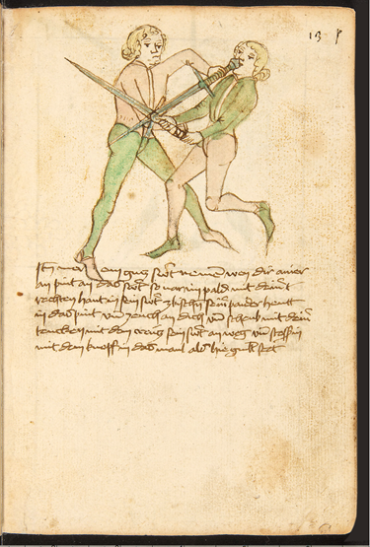

Figure 6

The hooded figures with the bizarre shields seen in the c. 1400 section of the Codex are repeated in versions of the German *Gladiatoria* such as M.S. Germ. Quart 16 c. 1435. The close-fitting skirted tunics/arming doublets are closed at the front and there are some indications that they are laced shut. Some also show traces of dagging along the bottom of the garment. The left-hand combatant in figure 33 clearly shows the lacing points attaching the hose to the doublet.

Some of the hose covers the whole foot, while others end in stirrups which go under the heel and leave most of the foot bare.

|  |  |
| --- | --- |
| Figure 7 | Figure 8 |

As noted above, several different versions of a manual attributed to Hans Talhoffer exist, his work falling within the Liechtenauer tradition. One of the earliest versions is the MS Chart. A. 558 c. 1443. The figures in this *fechtbuch* are quite similar to those seen in *Gladiatoria.* Like the *Gladiatoria* it includes combatants wielding the oversized dueling shields seen earlier, dressed in the tight fitting hood, tunic and hose which appear to be the standard uniform of the type. Several scenes deal with the preparations for a duel along with its gory results, showing how the points of the shield are used to full effect. Other figures (Figure 9) wear a skirted tunic or doublet that flares out over the lower torso and is drawn in tight at the waist, again suggesting that it might be padded like the *pourpoint* seen in Fiore. These garments are laced up the front like the examples seen in the 1435 *Gladiatoria* and some have a short standing collar.

Though not in the example included here, several figures show lacing points attaching the hose to the doublet. The combatants also wear the pointed shoes which seem to be common in Germany at this time.

The c. 1443 version of Talhoffer also contains several non-combatant figures (Figure10), and it is notable that their clothing differs considerably than that of those seen fighting. They wear knee length tunics, pleated down the front and belted at the hips. This contrast in tunics indicates that there was a difference between civilian and military garb at the time, with the tighter fitting outfits being intended to be worn under armour. Armoured combat does feature later on in the manual.

|  |  |
| --- | --- |
| Figure 9 | Figure 10 |

A later version of the Talhoffer *Fectbuch*, *M.S. Thott. 290.2* c. 1459, shows clothing much like that in figure 9 but in greater detail. Many of the combatants wear what appears to be a sleeveless doublet or jerkin with very short skirting, possibly over a second doublet of a different colour with a standing collar. Some of the jerkins are buttoned up the front while others are laced. Other figures wear just a doublet, sometimes loosely laced down the front. When a jerkin is worn, the hose are laced to it.

The hose worn are often parti-coloured, and some show more than one colour on one leg. Definite codpieces are also evident in the form of a triangular pouch over the groin. As in many of the other German examples discussed here, the figures wear pointed shoes.

The Talhoffer of 1459 is also notable for the great variety of hats seen in its illustrations. These include numerous short crowned hats with peaks and turned up brims, turbans, arming caps and round caps like the ones seen in figure 16. Some of the hats appear to have a fuzzy texture, perhaps indicating they are made of fur.

|  |  |
| --- | --- |
| Figure 11 | Figure 12 |

The *Kunst des Messerfechtens (CGM 582)* c. 1482 by Johannes Lecküchner is a *fechtbuch* on fighting with the *grosse messer*, essentially a very long knife with a single edge and a point much like that seen on a modern Bowie knife. The clothing in the illustrations, one of which is provided as figure 13, is seen repeatedly in late 15th and early 16th c. manuals in Germany. It consists of a tightly fitting doublet with very narrow skirting. The doublets have a U or V shaped opening at the front which extends to the waist, revealing a front-piece matching the colour of the hose. The material across the chest is sometimes slashed. The doublets have gaps under the arms. Sleeves often end partway down the forearm and sometimes have one or two slashes. Where the back of the garment can be seen there is also a V or U shape, sometimes extending as far as the waist, but sometimes ending mid-back.

The full length hose with codpiece are of a single colour and are laced to the doublet. In some examples a seam can be seen extending up the seat of the hose and another up the back of the legs. Again, the pointed shoe is in evidence, even in the images of those wearing armour, where steel has replaced leather or cloth.

Similar outfits can be seen in Peter Falkner’s *Kunste Zu Ritterlicher Were (MS KK5012)* c. 1495 (Figure 14)

|  |  |
| --- | --- |
| Figure 13 | Figure 14 |

After Fiore’s work there do not seem to be any other major works published on the martial arts in Italy until 1482, when Filipo Vadi’s *Liber de Arte Gladitoria Dimicandi* manuscript was created. Vadi’s work is very similar to that of the Fiore manual written over 70 years before. Some of the figures are even wearing crowns as in the *Flos Dulletorum*. The clothing depicted (Figure 15) is similar to that seen in Fiore’s work, a short, tight fitting garment worn over hose, though some important additions have been made. The figures are now definitely wearing doublets, some with skirts, and some without, closing at the front with buttons or possibly laces.

Many figures are wearing hose equipped with a fashionable codpiece, and the ties or lacing points that attach the hose to the doublet are clearly visible in many of the pictures. Some of the combatants wear slightly pointed shoes, like those seen in contemporary German manuals, while others just have the hose covering their feet.

Some of the combatants sport round caps on their heads, like the one seen in Luca Signorelli’s *Middle Aged Man* c. 1500 or Botticelli’s *Young Man with a Medallion of Cosimo de’ Medici* c. 1474 (fig 16). It is interesting to see the military underdress of Fiore’s day become the height of fashion in late 15th c. Italy.

|  |  |
| --- | --- |
| Figure 15 | Figure 16 |

The Sixteenth Century

In early 16th c. German *fechtbuchs* the clothing is similar to that of the late 15th c., but there is an increase in the complexity and diversity of garments. One change seen is an increase in images of slashed garments. Slashing was a technique by which cuts were made in the outer layer of a garment to allow the lining or undergarments to show through. Slashing of this fashion is associated with the Landsknechts, a type of soldier who originated in the various German states found to the north of Italy,. The Landsknechts were heavily involved in the fighting between France and the Hapsburgs, serving on both sides of the conflict. These troops employed the pike and shot tactics originated by the men of the Swiss Confederacy, who had become popular mercenary soldiers after numerous successes in battle. Though associated with the Landsknechts and their Swiss Confederacy opponents, the fashion of slashing may have started as a civilian fashion in Northern Italy where it is seen from about 1480 onwards[16].

One can speculate that the doublet would be made of felted wool, as it was best suited to the process of slashing whereas other materials might fray under the stress of day-to-day use, while the underlayers would be made of finer stuff like linen or damask,[17] though this may not always be the case. Juan de Alcega’s book on tailoring, the *Libro de Geometria, Pratica, Y Traca etc.,* shows patterns for cutting out doublets with slashed sleeves that are specifically referred to as being made of silk[18]. It would make sense that those who had the money would have access to better tailors and their garments made of finer stuff than the average foot soldier. There would also be less wear and tear on such garments than those worn by a soldier on campaign. Elements of Landsknecht fashion were even used in armour of the time, with the slashed clothing being replicated in metal[19].

Excellent examples of this diversity of early 16th c. German costume can be seen in the *Goliath (MS Germ.Quart.2020)* manuscript c. 1520 with its dozens of colour plates, two of which are included here as figures 17 and 18. Some of *Goliath*’s combatants wear outfits reminiscent of those seen in previous manuals like the Talhoffer’s 1443 manual, with tight fitting arming doublets laced to hose, though the inclusion of such archaic outfits may be an artefact of the process of copying from earlier books.

The majority of *Goliath* figures wear waist length doublets with various degrees of slashing on the front and back of the torso. A number of figures wear jerkins over their doublets; some slashed, some not. Some of the jerkins may be made of leather judging from their dull beige or brown colouration in the illustrations. The sleeves of most of the doublets are very broad at the shoulders, and have one or more gatherings down the arms. Many of the sleeves are slashed. It is difficult to tell how the doublets and jerkins are closed at the front and there do not seem to be any indications of buttons in the images. They may be laced closed; use a system of hooks and eyes; or even be seamed up the front. Some doublets are left open at the front showing the shirt underneath. Several of the jerkins are overlapped at the front, probably laced closed, and others show solid fronts. As well, many of the doublets are high enough at the waist to allow the wearer’s shirt to be exposed, puffing out between the doublet and hose. There are also examples of overgarments with long pleated skirting that are left open at the front. These garments were called “bases” by the English, and were sometimes replicated in steel for armour of the time period[20]. At least one figure is in their shirtsleeves, wearing no doublet at all.

There are also a variety of styles of hose including: solid coloured hose to the waist; particoloured hose; hose that is slashed above the knee and gartered below; as well as a short, breech like garment over the full length hose, like that seen in the section below on Marozzo. Almost all of the hose feature stuffed codpieces laced to the front of the hose; codpieces that are quite a bit more prominent than those seen in earlier manuals. There is also is a change in the style of shoes worn, with the pointed shoes seen earlier giving way to round fronted footwear, quite wide at the toe. These were said to resemble a cow’s mouth (*kuhmäule*) or bear’s paws (*barentätzen*)[21]. This type of shoe was imitated in the “bear paw” style *sabaton* foot armour seen during this time period[22].

*Goliath* shows a variety of hats, including arming caps, elaborate hoods, and round fur hats with turned up brims. One of the most common forms is a wide brimmed flat cap or *barett[23]*, often with slashing along the edges and copiously adorned with feathers. Sometimes the caps are worn over a *coif* or arming cap.

Figures wearing the same kinds of outfits are seen in the monumental series of woodcuts commissioned in 1512 by the Holy Roman Emperor Maximilian. Though not involved in the act of swordplay, they are specifically identified as fencers or *Gefechten[24]*. *Gefechten* were members of the fencing guilds that were encouraged by Maximilian, and may be compared to modern sports fencing or martial arts associations.

|  |  |
| --- | --- |
| Figure 17 | Figure 18 |

In the early 16th c. the first in a series of related printed fencing manuals appears in Italy. These are the manuals of the Dardi or Bolognese tradition mentioned previously. The earliest of these manuals is Antonio Manciolino’s *Opera Nova* of 1531. The printed images, an example of which is included as figure 19, are somewhat crude and open to interpretation, though some information can be gleaned from them. Many of the figures appear to be wearing a close fitting vest-like garment, possibly a jerkin, over a sort of shirt that extends to the mid-thigh. The vest closes up the front and there are indications of buttons. A number of the shirts, which appear to be short sleeved, have wavy lines on them that may indicate that they are actually made of mail, or chainmail as it is more commonly known today. Mail is composed of interlinked rings of iron or steel and was a fairly common form of body defence; though by the early 16th c. it had largely been replaced by plate armour at least among the knightly classes.

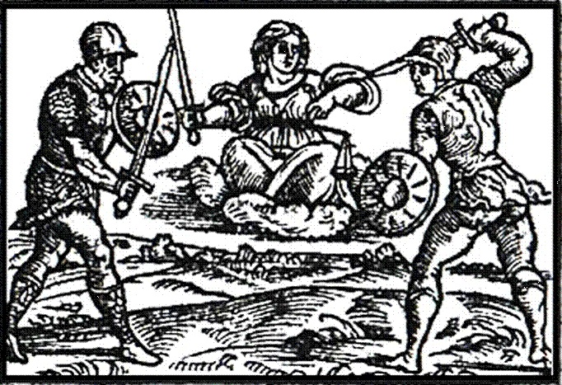

Figure 19

The figures in the illustrations wear tight fitting hose that extends up to the waist and some are shown wearing boots that come up to mid-calf. It also appears that many of the figures are wearing helmets rather than hats, possibly a form of sallet.

A second treatise on fencing in the Dardi tradition was written by Achille Marozzo and published in 1536, which was also known as the *Opera Nova*. It would be republished several times during the 16th c. including an edition with entirely new illustrations done on copperplate in 1568 as the *Arte dell'Armi di Achille Marozzo Bolognese[25]*.

The clothing portrayed in the 1536 version of Marozzo’s treatise, examples of which can be seen in figures 20 and 21, is similar in many ways to the German clothing discussed previously in this paper. The figures wear doublets that go down to the waist and across the small of the back, some of which have very short skirting. They have wide sleeves at the shoulder that narrow down to gather at the wrist. Many of them have elaborate patterns of slashing on the front, back and sleeves, similar to those seen in contemporary German manuals.

The doublets appear to have collars that extend to mid-neck and in some cases a shirt collar can be seen that has been tightly pleated along its edge. Many of the figures also appear to be wearing slashed jerkins often with scalloped edges, possibly made of leather, as was common among the Landsknechts.[26]

|  |  |
| --- | --- |
| Figure 20 | Figure 21 |

Two types of hose are worn by the figures in the *Opera Nova*. The first type is a full-length hose, laced to the doublet and slashed over the thighs, some with a garter just above the knee to keep the material from sagging similar to the majority of the hose in *Goliath*. The second type of hose seen consists of two parts, the first part being a full length set of hose over which is worn the second piece, a close fitting set of breeches which have been slashed. Only a few examples of this type of hose are seen in *Goliath*. Material is often pulled through the slashes, described by modern costumers as “puff and slash” fashion. Both types of hose feature prominent stuffed codpieces. The figures are wearing shoes that very much resemble modern carpet slippers, though quite broad across the toe. These are probably made of leather, and have also been slashed.

Hats in the *Opera Nova* seem to be a type of round flat cap with a short brim. These differ from the Landsknecht *baretts* seen in the *Goliath* manuscript. Both the Italian hats and the German were well feathered. Most of the pictures show the hat being worn level on the head but some figures wear their hats slightly tilted, and a few show it abruptly angled down one side of the head. The style of dress seems to have been found all over Western Europe, even as far away as England as can be seen in the portrait of Henry Howard, the Earl of Surrey c. 1546 (Figure22).

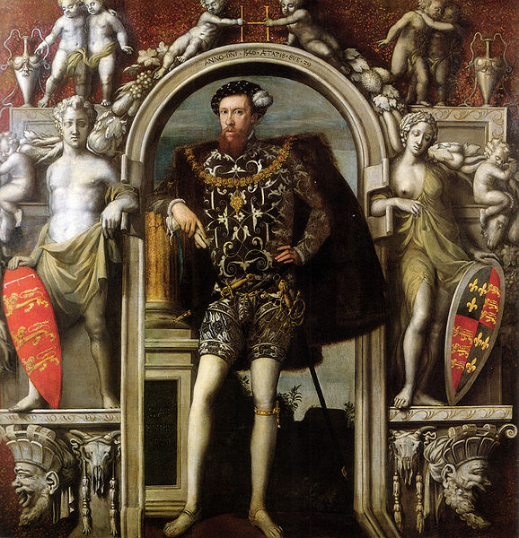

Figure 22

The 1568 edition of Marozzo’s treatise illustrates the evolution of fashion in Italy over the intervening 30 years as can be seen in figures 23 and 24. The doublets are of a similar cut to those seen in the 1536 edition, but they have lost the elaborate slashing of their predecessors. Some do show small cuts called “*pinkes*”.[27]They almost all possess narrow skirting descending two to three inches from the waist. The profile of the doublets is either flat or very gently curved. This gentle curve may indicate some form of padding. Many of the doublets have short secondary sleeves covering the upper part of the arm in various styles, and the sleeves themselves are more tightly fitted to the arm than seen in 1536. The standing doublet collar now covers the neck up almost to the chin, with a pleated shirt collar or possibly an early form of ruffshowing just above it. More detailed information on ruffs will be provided later in this paper.

One of the greatest differences between the images in the 1536 work and those in the 1568 treatise is the treatment of the legs, with two variations of hose. In the first variation the close fitting breeches of the *Opera Nova* have been replaced by trunkhose, a much more voluminous garment that balloons out from the top of the hips before being gathered in mid-thigh. Some examples are slashed or pinked, some show evidence of patterned material, while other examples are “paned”, composed of strips of cloth which are gathered at the waist and knee over a lining material. An excellent example of paned trunkhose can be seen in Janet Arnold’s *Patterns of Fashion: The Cut and Construction of for Men and Women c. 1560-1620*, in a suit once worn by Don Garzia, fourth son of Cosimo I de’Medici, who died in 1562[28]. Don Garzia’s outfit was constructed of velvet and the panes of the trunk hose were placed over a lining of satin[29]. Like the Don Garzia version, many of the trunkhose depicted in Marozzo’s 1568 work have distinct codpieces. The trunk hose appear to be worn over a second set of full length hose and both sets would probably be laced to the bottom of the doublet. The second type of hose is a much more close fitting form of breeches that are gathered at the top of the hips and below the knees. An example can be seen in the bottom left of figure 24. These are described by the Englishman Phillip Stubbes in his *Anatomie of Abuses (1583)* as “Venetian-hosen”,[30] and are often referred to by modern costumers as “Venetians.” The examples shown in the illustrations do not appear to have codpieces.

|  |  |
| --- | --- |
| Figure 23 | Figure 24 |

In addition to the hose on their legs, the figures are also wearing low cut shoes with no evidence of slashing.

Many of the figures are bareheaded but several wear hats. Most of them seem to be a narrow-brimmed cap, the top of which has been puffed up. Some of the hats are decorated with buttons or brooches and almost all of them have one or more feathered plumes. A similar hat can be seen in Francois Clouet’s sketch of the French King Charles IX c. 1560 (Fig 25), which shows a decorative band of trim just above the brim. His high collared doublet is also quite in keeping with those seen in Marozzo’s later work. This may indicate that French fashion may have had a greater influence by the latter half of the 16th c.

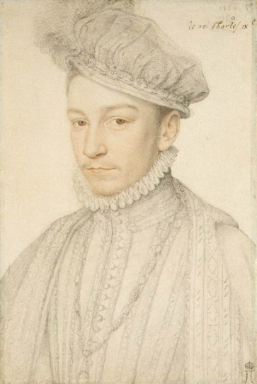

Figure 25

One of the next major fencing manuals is Camillo Agrippa’s *Trattato di scientia d’arme* published in 1553. Most of Agrippa’s figures are nude, but there are a series of plates showing fencers dressed in a very similar manner to Marozzo’s 1536 manual (Figures 26 and 27).

|  |  |
| --- | --- |
| Figure 26 | Figure 27 |

These plates show the same combination of a skirted doublet over either full length hose that had been slashed or over slashed short breeches and hose, both with codpieces along with slashed low-cut shoes. In contrast to the 1536 Marozzo, the doublets themselves do not seem to be slashed, though some figures wear a slashed jerkin over top of them. They actually bear a closer resemblance to the doublets seen in the reprint of Marozzo in 1556, possibly indicating a change in fashion, at least for the doublet. Two figures are wearing cloaks hung from one shoulder that descend to the knee or just below. A discussion of the importance of the cloak in fencing can be found later in this paper.

Another important fencing manual was Giacomodi Grassi’s *Ragione di adoprar sicurament el'Arme* published in 1570 and later translated into English and republished as *His True Arte of Defence* in 1594. The English edition uses a different set of illustrations than the Italian one. Italian edition images can be seen in Figures 28 and 29 and images from the English edition in Figures 30 and 31.

|  |  |
| --- | --- |
| Figure 28 | Figure 29 |

|  |  |
| --- | --- |
| Figure 30 | Figure 31 |

The images seen in the English edition of di Grassi’s work are considerably cruder than those found in the earlier work, which was possibly done on copper plate, whereas the later images appear to be woodcuts. There is certainly less detail in the English images, which omit important details such as how the hand grips the sword with the index finger hooked over the crossguard, something clearly illustrated in the Italian version of the treatise.

There are also some differences in the fashions illustrated in the two works. The 1570 edition shows clothing very similar to that seen in the 1568 version of Marozzo. The same types of doublets; trunk hose, paned and not; Venetians; shoes and even hats are in evidence. There are some indications that a second pair of short hose or stockings is being worn over the lower leg, gartered just below the knee. The similarities make sense as the two manuals were published very close in time and location.

The English clothing, while similar in some ways to the Italian version, has significant differences. The sleeves on the English doublets are much wider over the upper arms, giving them a looser appearance while still being gathered tightly at the wrist. They also lack secondary sleeves. Where the Italian doublets are flat at the belly or slightly rounded, the English appear to be well padded to almost a point, known as a *peascod* shape[31]. Some of the doublets are left partially unbuttoned either at the top or bottom. The English doublets also show a strip of material folded over the collar of the doublet, possibly what was known as a *falling band*, commonly found worn in England during later part of the 16th c. and which was pinned to the doublet[32].

The hose worn in the English manual is much like the Venetians seen in the earlier work by di Grassi, though they seem to be fuller and looser fitting, possibly a form of “Dutch slop”[33]with the lower legs probably being covered by stockings. Again, like in so many other manuals, the figures also wear low-cut, slipper- like shoes.

As noted above, not many of the German manuals were printed, which seems odd for an area which saw the birth of the printing press. This may indicate that the *fechtbuchs* were considered special knowledge, to be used only by those who were instructors or students of fencing, disseminated in the form of handwritten manuscripts. One important exception to this is Joachim Meyer’s *Gründtliche Beschreibung der Kunst des Fechtens* published in 1570 and based on a 1560 manuscript version of Meyer, the *Joachim Meyers Faktbok (MS A.4º.2)* written specifically for a group of Meyer’s students[34]. The 1570 treatise expands on the earlier work and contains dozens of woodcut diagrams, significantly using a lettering system to refer to the text, as did Agrippa. It is also one of the first German texts to include Italian single-handed sword techniques, even adopting some of the terminology from the Italian treatises.

The clothing in Meyer (Figures 32, 33, 34, 35) shows the development of German fashion towards the end of the 16th c. Some of the doublets the combatants wear are extensively slashed but others have minimal slashing or are smooth, and the profile of the doublets is relatively flat compared to those seen in the 1594 version of Di Grassi. All of the doublets show thin skirting covering the lacing points for the hose. Many of the figures wear slashed leather jerkins over their doublets, and both doublets and jerkins show evidence of button closures, though many of the doublets and jerkins are left open at the front. The figures also show either a small ruff or a falling band/collar at the neck.

The hose the fencers wear is of a type not seen in the earlier German manuals examined here. This type of hose is referred to as *pluderhosen[35]*,and was the ultimate expression of the concept of “puff and slash”. Like trunkhose, *pluderhosen* are composed of panes of material gathered at the waist and just above the knee. Unlike trunkhose, the lining material of the hose is pulled out in puffs between the panes. The illustrations show how the *pluderhosen* bag out at the bottom to droop over the knee. The prominent codpiece also has decorative slashes with puffs of material. Several sets are examined in Arnold’s *Patterns of Fashion 1560-1620* which belonged to members of the Sture family, who were unfortunately murdered in Uppsala Cathedral in 1567[36]. The clothing remained with the church: the knife rents and bloodstains intact for future generations wishing to play *CSI: Uppsala.* The Sture’s doublets and *pluderhosen* were constructed of velvet, and Arnold indicates other examples going back to the 1550s[37]. The slashed shoes worn by the figures are like those worn in contemporary Italian manuals, having lost the broad toe seen in the *Goliath* shoes, but not with the exaggerated point of 15th c. German shoes.

While most figures in Meyer are bareheaded, some do wear hats, with the most common type seen in the illustrations being caps like the one seen in figure 25.

|  |  |
| --- | --- |
| Figure 32 | Figure 33 |
| Figure 34 | Figure 35 |

In Italy, Angelo Viggiani’s *Lo schermo* was published in 1575 and is considered part of the Dardi tradition. The treatise contains only seven illustrations of human figures, but they are worth discussing for the variety of clothing they wear and four of them have been included here for comparison. Several of the figures (Fig 36 and 37) wear an outfit composed of a doublet over trunkhose. Over the doublet there appears to be a jerkin that buttons at the front; one of these is pinked. The trunk hose worn by one figure appears to have *canions*, short sleeves of material that extend down to the knee from where the trunk hose is gathered at mid-thigh[38]. Lacing points can also be seen at the waist of one jerkin. One of the illustrations shows separate stockings overlapping the bottom of the canions, gartered at the knee.

The two other figures in Vigianni’s treatise are quite Germanic in appearance. Briefly, their clothing shows the more exaggerated slashing of the German fashion. Doublets are slashed and material is pulled through to form puffs. Also, the hose is much baggier than seen in the Viggiani’s other illustrations, very much in keeping with German costume of the late 16th c. Figure 20 appears to be wearing *pluderhosen*, like that seen in Meyer’s 1570 *fechtbuch*. All of the figures wear slipper-like shoes and there is evidence that they are slashed.

Headgear is also varied. Some examples of hats are like those seen in figure 12. In addition there are brimless, conical fur hats with high crowns.

The images from Viggiani’s treatise show the variety of clothing that could be seen in Italy in the latter half of the 16th c., with influences from Italy, France, and Germany.

|  |  |
| --- | --- |
| Figure 36 | Figure 37 |

|  |  |
| --- | --- |
| Figure 38 | Figure 39 |
|  |  |

Another manual that is worth noting is Frederico Ghisliero’s *Regole di molte cavagliere schiesser citii* published in 1587.The original edition lacked illustrations, but shortly afterward a second edition with pen and wash drawings was released[39]. Some examples of these figures can be seen in Figure 40. The outfits are similar to those seen in the 1594 edition of di Grassi, featuring peascoded doublets with short skirting and belted at the point where the skirts attach to the doublet. Some figures appear to be wearing ruffs, a pleated length of starched linen attached to a cloth band which is pinned to the doublet at the neck[40].

The figures wear Venetians, some of which are gartered below the knees and the slipper-like shoes that appear to be a common type for the time period.

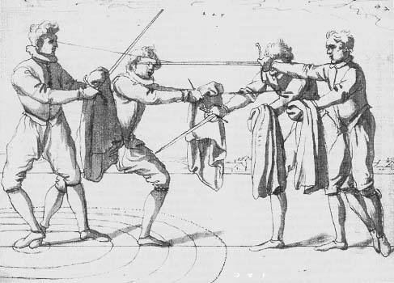

Figure 40

One of the last manuals published in the 16th c., and the first one written from scratch in English, is *Saviolo, his Practice* written by Vincentio Saviolo and published in 1595.A plate from the manual has been include as figure 41. The men in the illustrations wear peascoded doublets similar to those seen in di Grassi’s English treatise, with the addition of small flaps where the sleeves attach to the body of the doublet. They also wear what appear to be falling bands at their necks.

The many of figures wear Venetian-type hose but a number of the examples seen in Saviolo are left open at the bottom rather than being gathered as is seen in examples from other manuals. Some of the Venetians show buttons at the knee, but they are left unbuttoned. Some figures wear stockings that go to mid-thigh, being pulled over the venetians and then gartered. There are also examples of trunkhose. Like the fencers in many of the other manuals examined, Saviolo’s illustrations show the simple slipper-like shoe.

One thing that sets Saviolo’s pictures apart from those seen in earlier manuals is the very tall, broad brimmed hats worn by the figures in his treatise, featuring hatbands and multiple plumes. These are the same hats seen worn in the Lant Roll that recorded the funeral procession of Sir Phillip Sydney, who was killed in battle in 1586[41]. An image from this source is included as figure 42.

|  |  |
| --- | --- |
| Figure 41 | Figure 42 |

The Seventeenth Century

Moving into the early part of the 17th c. we have manuals like Salvatore Fabris’ magnificent 1606 manual *Scienza e practica d’arme* which, unfortunately, is of no use for the purposes of this paper as the literally hundreds of figures it contains are all nude. Fortunately, Ridolofo Capo Ferro’s 1610 work the *Gran Simulacro dell’arte e dell’uso della Scherma*, while containing mostly nude or minimally clad figures, does have some that are useful for this paper. One plate on holding the sword (Figure 43) and two plates on the use of the sword and cloak contain fully clothed figures while a fourth plate contains two figures dressed in what can only be described as antique military dress.

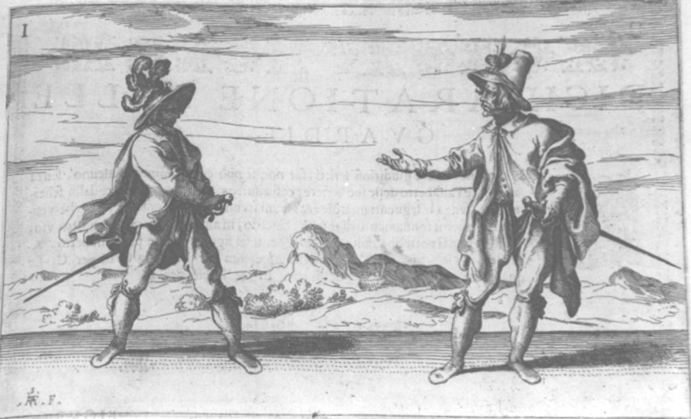

Figure 43

The two well-dressed gentlemen of the first plate are interesting in that they wear a number of layers of clothing. There is evidence of a doublet peeking out on one figure and both figures wear what appears to be a cassock. In the early 17th c. the cassock had yet to become associated with the priesthood. It was a garment that varied in length but at this time it was usually found coming to just below the waist. Unlike a jerkin, a cassock was not tightly fitted to the waist. The patterns for several types of cassocks can be found in the tailor’s book of Juan de Alcega mentioned above[42]. Also, the men pictured in the Lant Roll (Fig 25) are described as wearing cassocks[43].

One figure wears a cloak that goes to mid-thigh while the other wears what could be a loose robe. Long robes worn over doublets are illustrated in Vecellio’s costume book[44] (Figure44).

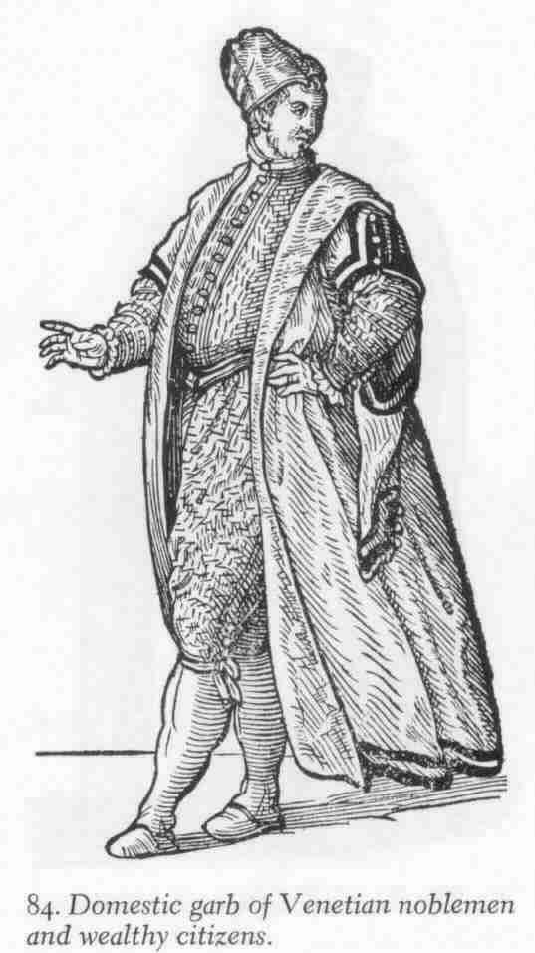

Figure 44

It could also be a heavier cloak referred to as a *Herreruelo* cloak in Alcega[45]. These sorts of long cloaks are mentioned in Stubbs “…and other some traylinge uppon the ground (almost) liker gownes, than cloakes.”[46]It may be that the one fencer is wrapping part of the cloak around his left arm to keep it from becoming a tripping hazard. Cloaks were often used as emergency defensive devices when another off hand weapon like a dagger was not available[47]and several manuals cover their use as such, including those of Ghisliero (Figure40) and Capo Ferro. The cloak was usually wrapped around the arm and used to deflect thrusts or continue a parry after the sword had already taken the brunt of a cut[48]. Most cloaks used in fighting were the shorter, half cloak, of hip or mid-thigh length, as longer cloaks would encumber the arm and tire it out with their greater weight of material[49].

Most of the figures wear Venetian-like breeches, but baggier, gartered at the knee. At least one figure wears short but ragged trunkhose and no shoes, but the other figures wear the seemingly ubiquitous late 16th c. and early 17th c. slipper-like shoe. Shoes of this type might be considered an artist’s shorthand to simplify the drawing process, but they are found in numerous paintings during the second half of the 16th c., one example being the full length portrait of Sir Martin Frobisher by Cornelius Ketel c. 1577 (Fig 45).

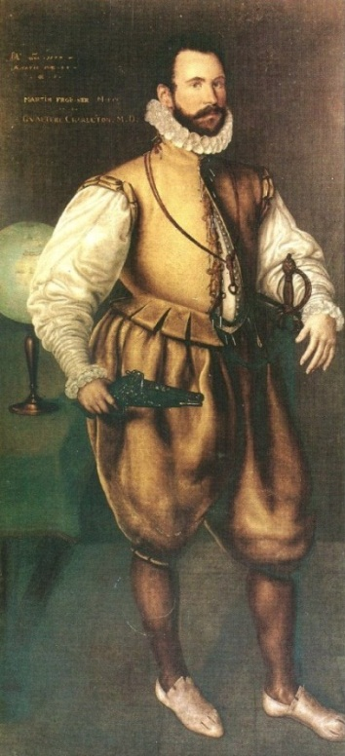

Figure 45

Analysis

The Italian and German manuals examined in this paper show us a very definite evolution in fashion during the two hundred years they cover. From the simple costume of the *Flos Dulletorum* and the *Gladitoria*,to the multi-layered clothing seen in the *Gran Simulacro* and Meyer’s *fechtbuch,* we see that people involved in the act of combat wore a number of different styles of clothing that increased in complexity over time. Especially in the 15th c. we see the transition of military clothing to civilian use, just as we see civilian costume affect that worn by soldiers.

One question that must be answered is why particular clothing choices were made by those involved in the act of combat, or whether choice was involved at all. It is important to understand the contexts in which combat took place and what influences those contexts have on the clothing worn.

Combat can be deadly earnest or simply for practice, and the manuals studied in this paper witness this duality. Many of them merely show the different poses of a particular technique like Meyer’s *fechtbuch*, while others, like the 1459 version of Talhoffer and later Capo Ferro, graphically show blows being struck including spurting blood, limb removal and decapitation effects.

In Talhoffer, we see a manual designed to prepare a person for the legal procedure known as the judicial duel, often better known as trial by combat. The judicial duel was essentially a means by which disputes could be settled, as the victor in the combat would be in the right in the eyes of God. His unfortunate opponent, if he survived the duel, would be hung[50]. As seen in Talhoffer those of noble birth often fought fully armoured, but those of lesser birth also had recourse to this legal means, and the manuals seem to indicate the uniform set of garments for the fight was a skintight hooded tunic and hose. While many involved in such duels could seek a champion to take their place[51] those who could not find one had to fight it out, including women, whose methods of fighting in a trial are covered by Talhoffer. Schools rose up to train professional champions[52], and in these schools we see the first organized classes requiring visual aids like the early *fechtbuchs*. Yet, as violent as they were, the judicial duel took place under very controlled circumstances, and the images in Talhoffer even show a fenced ring in which the combat would take place.

Capo Ferro’s book graphically prepares readers for the affray and the duel. His work shows figures in the heat of combat, and the unfortunate results that occur when a combatant makes a mistake. Settling disputes with the sword became almost epidemic by the close of the 16th c. According to one source, over 4000 members of the French nobility were killed in private combats between 1590 and 1610[53]. By the late 16th c. century wearing a sword in public had become very common, and all too frequently simple disputes would lead to bloodshed. Formal duelling codes were established, despite the practice being outlawed in most states. The schools that had once trained professional fighters now catered to the new amateur market. Private duels, sometimes called *duello alla macchia,* because they occurred in out-of-the-way places[54], were bloody affairs and in a way this is seen in the desperate expressions of the men pictured in Capo Ferro. The men in Figure 43 are about to commence a fight and they are wearing the same clothes as they would in everyday life. Some accounts of duels, like that between Sir Edward Sackville and Lord Bruce in 1610, indicate that the duellists removed their doublets before fighting[55], but for the most part the figures seen in fencing manuals retain theirs.

Even the private duel took place under somewhat controlled circumstance with the combatants having seconds, agreeing to terms and often having physicians in attendance. Often those niceties were unavailable for those who found themselves in a fight. Many fights were sudden, brutal affairs, occurring in the heat of the moment, like the encounter between Christopher Marlow and William Bradley in Hog Lane in 1589. A third man, Thomas Watson, intervened and was severally wounded in the process, but not before killing Bradley[56]. An example from literature is the famous fight between Romeo and Tybalt in *Romeo and Juliet*. Romeo seeks out Tybalt to avenge the death of his friend Mercutio. Before the fight Romeo states: ‘Now Tybalt, take the “villain” back again that thou gavest me, for Mercutio’s soul is but a little way above our heads, staying thine to keep him company. Either thou or I, or both must go with him.[57]’ He obviously intends to kill Tybalt and he succeeds. Such acts of sudden violence would force to combatants to fight in whatever they were wearing at the time, most likely the same clothes they wore in their daily lives. It would be difficult to remove a doublet during a fight, even if it was restrictive, because it was probably laced to the fighter’s hose.

In some regions, like Germany, fencing moved away from being in deadly earnest, becoming more like a sport, though a sport that still had inherent risks. We see the rise of societies of fencers, like the Brotherhood of St. Mark or the *Marxbrudder,* and the Fencers of the Feather or the *Federfechter[58]* and regular fencing competitions known as *Fechtschules*. The violent, bloody, images seen in Talhoffer give way to the fashionably dressed gentlemen at practice seen in Meyer’s *fechtbuch*. The *fechtschules* were like martial arts tournaments, with prizes for the victors. Although violent affairs, with a victory declared by the infliction of a bloody head wound, these were rarely fatal.

What can the SCA fencer take away from the material explored in this paper? There was a wide variety of costume worn during the period when fencing manuals were written, which in turn gives the SCA fencer many options when considering clothing for the list. With a few exceptions; like the “uniform” of the German judicial duel or pourpoint seen in the early 15th c. manuals, people in the act of civilian combat wore the same clothes they did in their everyday lives. The images in the fencing manuals and *fechtbuch* show men wearing clothing that was the height of fashion for their day, and if forced to fight it would be the same clothing they would be wearing during the combat.

Also, similar clothing is worn at similar times in both Germany and Italy throughout the 200 years this paper covers. There are some regional variations, such as trunkhose vs. *pluderhose* late in period, but the basic components of doublet, jerkin and hose are very comparable. There are even many similarities in headwear and footwear.

The fencing manuals and *fechtbuchs* produced between 1400 and 1610 offer a wonderful window on the clothing of that time period. Of course other sources of images exist, but the books on fencing specifically deal with what was worn during the act of combat, thus making them of great utility to the fencer who wishes to make their clothing as authentic as possible. It is very satisfying to be able to open a treatise on fencing, point to an image of a person in the act of combat and say “There, that is what I’ve based my clothing on.”

List of Illustrations

Figure 1 *FlosDuellatorum (Pisani-Dossi MS)*Folio 20v <http://wiktenauer.com/wiki/File:Pisani-Dossi_MS_20v.JPG>

Figure 2 *Fior di Battaglia (MS M.383)* Folio 14r <http://ica.princeton.edu/images/morgan/m383.014r.jpg>

Figure 3 *Florius de Arte Luctandi (MS Latin 11269)*<http://visualiseur.bnf.fr/ConsulterElementNum?O=22027985&E=JPEG&Deb=1&Fin=1&Param=B>

Figure 4 *Codex Wallerstein Folio 80r* <http://media.bibliothek.uni-augsburg.de/file/82798/841637414081.png>

Figure 5 *Codex Wallerstein Folio 99r* <http://media.bibliothek.uni-augsburg.de/file/82836/02864928224.png>

Figure 6 *Codex Wallerstein Folio 13r* <http://media.bibliothek.uni-augsburg.de/file/82664/0260536000355.png>

Figure 7 *Gladiatoria (M.S. Germ. Quart 16) c. 1435-1440*<http://www.thearma.org/Manuals/Gladiatoria/Gladiatorie_part5.htm>

Figure 8 *Gladiatoria (M.S. Germ. Quart 16) c. 1435-1440*<http://www.thearma.org/Manuals/Gladiatoria/Gladiatorie_part6.htm>

Figure 9 *Talhoffer Fechtbuch (M.S. Chart. A. 558) c. 1443 plate 3*<http://jfgilles.perso.sfr.fr/escrime/bibliotheque/talhoffer_gotha/index.html>

Figure 10 *Talhoffer Fechtbuch (M.S. Chart. A. 558) c. 1443 plate 10*<http://jfgilles.perso.sfr.fr/escrime/bibliotheque/talhoffer_gotha/index.html>

Figure 11 *Talhoffer Fechtbuch (M.S. Thott.290.2) c. 1459*<http://www.salafenix.eu/docs/biblio/tratados/Hans_Talhoffer.Alte_Armatur_und_Ringkunst.1459.Original.al.pdf>

Figure 12 *Talhoffer Fechtbuch (M.S. Thott.290.2) c. 1459*<http://www.salafenix.eu/docs/biblio/tratados/Hans_Talhoffer.Alte_Armatur_und_Ringkunst.1459.Original.al.pdf>

Figure 13 *Kunst des Messer fechtens (Cgm 582) c. 1482* <http://www.hroarr.com/manuals/liechtenauer/Leckuchner-Hans-Cgm-582-1482.pdf>

Figure 14 *Meister peter falkners kunste Zu Ritterlicher Were (M.S. KK5012) Folio 9v*<http://wiktenauer.com/images/4/40/MS_KK5012_9v.jpg>

Figure 15 *Liber de Arte Gladitoria Dimicandi* Recto 19 <http://www.thearma.org/Manuals/VadiNewImages/Untitled-4B.jpg>

Figure 16 Sandro Botticelli *Portrait of a Man with a Medal of Cosimo the Elder c. 1474*<http://en.wikipedia.org/wiki/File:Sandro_Botticelli_074.jpg>

Figure 17 *Goliath (MS Germ.Quart.2020) c. 1510-1520 Folio 11v* <http://wiktenauer.com/wiki/File:MS_Germ.Quart.2020_11v.jpg>

Figure 18 *Goliath (MS Germ.Quart.2020)c. 1510-1520 Folio 26r* <http://wiktenauer.com/wiki/File:MS_Germ.Quart.2020_26r.jpg>

Figure 19 Antonio Manciolino *Opera Nova* <http://wiktenauer.com/wiki/File:Antonio_Manciolino.jpg>

Figure 20 Achille Marozzo *Opera Nova (1536)* <http://wiktenauer.com/wiki/File:Marozzo_2.png>

Figure 21 Achille Marozzo *Opera Nova (1536)* <http://wiktenauer.com/images/9/93/Marozzo_10.png>

Figure 22 Unknown Flemish Artist *Henry Howard, Earl of Surrey*<http://upload.wikimedia.org/wikipedia/commons/5/57/Henry_Howard_Earl_of_Surrey_1546.jpg>

Figure 23 Achille Marozzo *Arte dell'Armi di Achille Marozzo Bolognese (1568)*<http://www.thearma.org/Manuals/NewManuals/Marozzo/p035.jpg>

Figure 24 Achille Marozzo *Arte dell'Armi di Achille Marozzo Bolognese (1568)* <http://www.thearma.org/Manuals/NewManuals/Marozzo/p012.jpg>

Figure 25 Francois Clouet Portrait of Charles IX c. 1560 <http://www.wga.hu/frames-e.html?/html/c/clouet/francois/index.html>

Figure 26 Camillo Agrippa *Trattato di scientia d’arme* <http://www.thearma.org/Manuals/NewManuals/Agrippa/p108.JPG>

Figure 27 Camillo Agrippa *Trattato di scientia d’arme* <http://www.thearma.org/Manuals/NewManuals/Agrippa/p118.JPG>

Figure 28 Giacomo di Grassi *Ragione di adoprar sicuramente l'Arme* <http://www.jaredkirby.com/images/diGrassi_guardia.jpg>

Figure 29 Giacomo di Grassi *Ragione di adopra rsicuramente l'Arme* <http://www.thearma.org/Manuals/NewManuals/DiGrassi/03001034.jpg>

Figure 30 Giacomo di Grassi *His True Arte of Defence* <http://wiktenauer.com/images/2/23/Di_Grassi_16.jpg>

Figure 31 Giacomo di Grassi *His True Arte of Defence* <http://wiktenauer.com/images/8/8a/Di_Grassi_15.jpg>

Figure 32-35 Gründtliche Beschreibung der Kunst des Fechtens <http://www.hroarr.com/manuals/liechtenauer/joachim-meyer-1570.pdf>

Figure 36 -39 Angelo Viggiani *Lo Schermo* <http://www.hroarr.com/manuals/fiore/Viggiani_1575.pdf>

Figure 40 Frederico Ghisliero *Regole di molte cavagliere schiesser citii* <http://www.thearma.org/essays/Regole.htm>

Figure 41 Vincentio Saviolo *Saviolo his Practice* <http://wiktenauer.com/wiki/File:Saviolo_4.jpg>

Figure 42 Lant Roll <http://www.employees.org/~cathy/images/lant_roll1.jpg>

Figure 43 Capo Ferro *Gran Simulacro dell’arte e dell’uso della Scherma* <http://www.thearma.org/Manuals/NewManuals/CapoFerro/10001051.jpg>

Figure 44 Cesare Vecellio *Plate 84 Domestic garb of Venetian noblemen and wealthy citizens* <http://lochac.sca.org/rapier/index.php/Bella-SCA-Rapier-Garb-from-fighting-to-feasting>

Figure 45 Cornelius Kettle *Portrait of Sir Martin Frobisher c. 1577* <http://upload.wikimedia.org/wikipedia/commons/0/08/Martin_Frobisher_by_Ketel.jpg>

Bibliography

Amberger,J. Christoph “Duel Between Sir Edward Sackville and Lord Bruce, A.D. 1610.” *The Secret History of the Sword: Adventures in Ancient Martial Arts.* Burbank: Multi-Media Books Inc., 1999.

Amberger, J. Christoph “Dead Poets Society: Rencontre in Hog Lane, A.D. 1589” *The Secret History of the Sword: Adventures in Ancient Martial Arts.* Burbank: Multi-Media Books Inc., 1999.

Amberger, J. Christoph “A Fechtschule in Late 16th-Century Germany” *The Secret History of the Sword: Adventures in Ancient Martial Arts.* Burbank: Multi-Media Books Inc., 1999.

Anglo, Sydney *The Martial Arts of Renaissance Europe.* New Haven: Yale University Press, 2000.

Appelbaum, Stanley (trans.) *The Triumph of Maximilian: 137 Woodcuts by Hans Burgkmair and Others.* New York: Dover Publication, Inc., 1964.

Arnold, Janet *Patterns of Fashion 4: The Cut and Construction of Linen Shirts, Smocks, Neckwear, Headwear and Accessories for Men and Women c. 1540-1660.* London: Pan Macmillan Ltd, 2008.

Arnold, Janet *Patterns of Fashion: The Cut and Construction of for Men and Women c. 1560-1620.* London: Macmillan Publishers Ltd, 1985.

Arnold, Thomas *The Renaissance at War.* London: Cassel & Co., 2001.

Baldrick, Robert *The Duel: A History of Dueling.* London: The Shenval Press, 1965.

Boucher, Francois *20,000 Years of Fashion: The History of Costume and Personal Adornment.* New York: Harry N. Abrams Inc., 1987.

Colaianne, A.J. and W.L. Godshalk (ed.) *Elegies for Sir Phillip Sydney (1587).*New York: Scholar’s Facsimiles & Reprints, 1980.

Cornish, Paul *Men-at-Arms Series 191: Henry VIII’s Army.* London: Osprey Publishing Ltd, 1987.

Edge, David and John Miles Paddock *Arms and Armour of the Medieval Knight.* London: Bison Books, 1988.

Hale, John *The Civilization of Europe in the Renaissance* Toronto: Simon & Schuster, 1993.

Pain, Jean and Cecilia Bainton (trans.) *Juan de Alcega’s Tailor’s Pattern Book 1589.* New York: Costume & Fashion Press, 1999.

Patterson, Angus *Fashion and Armour in Renaissance Europe: Proud Looks and Brave Attire.* London: V&A Publishing, 2002.

Richards, John *Osprey Warrior Series 49: Landsknecht Soldier 1486-1560.* Oxford: Osprey Publishing, 2002.

Shakespeare, William *The Tragedy of Romeo and Juliet.* New York: Washington Square Press, 1965.

Stamper, David *Cloaking Devices: A Comparison of Historical and SCA Techniques.* Guelph: Self Published, 2011.

Jeffrey L. Singman *Ye Englishe Breviat: A Concise Guide to Elizabethan and Stuart Living History c. 1585-1645.* Kingston: The Trayn’d Bandes of London, 1995.

Tincey, John *The Armada Campaign 1588: Osprey Elite Series 15.* London: Osprey Publishing, 1988.

Turner, Craig and Tony Soper *Methods and Practice of Elizabethan Swordplay.* Chicago: Southern Illinois University, 1990.

Vecellio,Cesare *Vecellio’s Renaissance Costume Book.* New York: Dover Publications, Inc., 1977

Online Resources

The Association for Renaissance Martial Arts (ARMA) (<http://www.thearma.org>)

<http://www.thearma.org/Manuals/NewManuals/Agrippa/agrippa.htm>

<http://www.thearma.org/Manuals/NewManuals/CapoFerro/capoferro.htm>

<http://www.thearma.org/Manuals/NewManuals/DiGrassi/digrassi.htm>

<http://www.thearma.org/Manuals/Gladiatoria/Gladiatoria.htm>

<http://www.thearma.org/manuals.htm>

<http://www.thearma.org/Manuals/NewManuals/Marozzo/marozzo.htm>

<http://www.thearma.org/essays/Regole.htm>

<http://www.thearma.org/Manuals/Vadi.htm>

Wiktenauer (<http://wiktenauer.com/wiki/Main_Page>)

<http://wiktenauer.com/wiki/Antonio_Manciolino>

<http://wiktenauer.com/wiki/Fencing_manual>

<http://wiktenauer.com/wiki/Fiore_de'i_Liberi>

<http://wiktenauer.com/wiki/Florius_de_Arte_Luctandi_(MS_Latin_11269)>

<http://wiktenauer.com/wiki/Flos_Duellatorum_(Pisani-Dossi_MS)>

<http://wiktenauer.com/wiki/Giacomo_di_Grassi>

<http://wiktenauer.com/wiki/Gladiatoria_(MS_Germ.Quart.16)>

<http://wiktenauer.com/wiki/Goliath_(MS_Germ.Quart.2020)>

<http://wiktenauer.com/wiki/Gran_Simulacro_dell%27Arte_e_dell%27Uso_della_Scherma_(Ridolfo_Capo_Ferro_da_Cagli)>

<http://wiktenauer.com/wiki/Hans_Talhoffer>

<http://wiktenauer.com/wiki/Joachim_Meyers_Faktbok_(MS_A.4%C2%B0.2)>

<http://wiktenauer.com/wiki/Kunste_Zu_Ritterlicher_Were_(MS_KK5012)>

<http://wiktenauer.com/wiki/Liechtenauer%27s_zettel#Epitome>

<http://wiktenauer.com/wiki/Marozzo>

<http://wiktenauer.com/wiki/Opera_Nova_(Achille_Marozzo)>

<http://wiktenauer.com/wiki/Talhoffer_Fechtbuch_(MS_Chart.A.558)>

<http://wiktenauer.com/wiki/Talhoffer_Fechtbuch_(MS_Thott.290.2%C2%BA)>

<http://wiktenauer.com/wiki/Sch%C3%B6ffer_Fechtbuch_(8_ARS_MIL_1090/61)>

<http://wiktenauer.com/wiki/Vincentio_Saviolo>

HROARR (<http://www.hroarr.com/> )

<http://hroarr.com/manuals/liechtenauer/joachim-meyer-1560.pdf>

<http://www.hroarr.com/manuals/liechtenauer/Leckuchner-Hans-Cgm-582-1482.pdf>

<http://www.hroarr.com/manuals/fiore/Viggiani_1575.pdf>

Other

Anderson, Margo “Fabric Manipulation” *Elizabethan Costume: History and Techniques*<http://www.directcon.net/wander/liztrim.htm>

Torfason, Ragnar “slop, sloppe, slops” *Tempus' Sewing & Garb Accessories Weeb Site* <http://www.theweebsite.com/sewing/leggings/slops.html>

Wake, Anabella “Build: SCA Rapier Garb – From Fighting to Feasting” <http://lochac.sca.org/rapier/index.php/Bella-SCA-Rapier-Garb-from-fighting-to-feasting>

<http://www.employees.org/~cathy/images/lant_roll1.jpg>

<http://en.wikipedia.org/wiki/File:Sandro_Botticelli_074.jpg>

<http://ica.princeton.edu/images/morgan/m383.014r.jpg>

<http://www.jaredkirby.com/images/diGrassi_guardia.jpg>

<http://jfgilles.perso.sfr.fr/escrime/bibliotheque/talhoffer_gotha/index.html>

<http://media.bibliothek.uni-augsburg.de/file/82664/0260536000355.png>

<http://media.bibliothek.uni-augsburg.de/file/82836/02864928224.png>

<http://media.bibliothek.uni-augsburg.de/file/82798/841637414081.png>

<http://www.salafenix.eu/docs/biblio/tratados/Hans_Talhoffer.Alte_Armatur_und_Ringkunst.1459.Original.al.pdf>

<http://www.umass.edu/renaissance/lord/pdfs/Leckuchner_Lebkommer_1558.pdf>

<http://upload.wikimedia.org/wikipedia/commons/5/57/Henry_Howard_Earl_of_Surrey_1546.jpg>

<http://upload.wikimedia.org/wikipedia/commons/0/08/Martin_Frobisher_by_Ketel.jpg>

<http://visualiseur.bnf.fr/ConsulterElementNum?O=22027985&E=JPEG&Deb=1&Fin=1&Param=B>

<http://www.wga.hu/frames-e.html?/html/c/clouet/francois/index.html>

1. John Hale *The Civilization of Europe in the Renaissance* (Toronto: Simon & Schuster, 1993) 546
2. Thomas Arnold *The Renaissance at War* (London: Cassel & Co., 2001), 143
3. Hale; 282
4. Sydney Anglo *The Martial Arts of Renaissance Europe* (New Haven: Yale University Press, 2000) 48
5. Ibid
6. Ibid, 52
7. Ibid; 22
8. Various Authors *Wiktenauer* “Johannes Liechtenauer” <http://wiktenauer.com/wiki/Liechtenauer%27s_zettel#Epitome> accessed 13 October 2012
9. Various Authors *Wiktenauer*<http://wiktenauer.com/wiki/Hans_Talhoffer>accessed 15 October 2012
10. Various Authors *Wiktenauer*“Der AltennFechteranfenglichekunst”; accessed 16 October 2012
11. Various Authors, *Wikipedia*<http://en.wikipedia.org/wiki/Fiore_dei_Liberi>; accessed 7 October 2012
12. Various Authors *Wiktenauer*<http://wiktenauer.com/wiki/Florius_de_Arte_Luctandi_(MS_Latin_11269)>; accessed 7 October 2012
13. Francois Boucher *20,000 Years of Fashion: The History of Costume and Personal Adornment* (New York: Harry N. Abrams Inc., 1987) 196
14. David Edge and John Miles Paddock *Arms and Armour of the Medieval Knight* (London: Bison Books, 1988) 93
15. Cesare Vecellio *Vecellio’s Renaissance Costume Book* (New York: Dover Publications, Inc., 1977) 12-14
16. John Richards *Osprey Warrior Series 49: Landsknecht Soldier 1486-1560* (Oxford: Osprey Publishing, 2002) 31
17. Ibid.
18. Jean Pain and Cecilia Bainton (trans) *Juan de Alcega’s Tailor’s Pattern Book 1589* (New York: Costume & Fashion Press, 1999) 22
19. Patterson; 38
20. Paul Cornish *Men-at-Arms Series 191: Henry VIII’s Army* (London: Osprey Publishing Ltd, 1987) 37
21. Richards; 42
22. Patterson; 35
23. Richards; 42
24. Stanley Appelbaum (trans.) *The Triumph of Maximilian: 137 Woodcuts by Hans Burgkmair and Others* (New York: Dover Publication, Inc., 1964) 7
25. Various Authors “Opera Nova (Achille Marozzo)” *Wiktenauer* [*http://wiktenauer.com/wiki/Opera_Nova_(Achille_Marozzo)*](http://wiktenauer.com/wiki/Opera_Nova_(Achille_Marozzo)); accessed 8 October 2012
26. Richards; 62
27. Margo Anderson “Fabric Manipulation” *Elizabethan Costume: History and Techniques* <http://www.directcon.net/wander/liztrim.htm>; accessed 8 October 2012
28. Janet Arnold *Patterns of Fashion: The Cut and Construction of for Men and Women c. 1560-1620* (London: Macmillan Publishers Ltd, 1985) 53
29. Ibid.
30. Ibid. 86
31. Angus Patterson *Fashion and Armour in Renaissance Europe: Proud Looks and Brave Attire* (London: V&A Publishing, 2002) 45
32. Jeffrey L. Singman *Ye Englishe Breviat: A Concise Guide to Elizabethan and Stuart Living History c. 1585-1645* (Kingston: The Trayn’d Bandes of London, 1995) 24
33. Ragnar Torfason “slop, sloppe, slops” *Tempus' Sewing & Garb Accessories Weeb Site* accessed 13 October 2012 <http://www.theweebsite.com/sewing/leggings/slops.html> accessed 10 October 2012
34. Various Authors *The Wiktenauer* “Joachim Meyer’s Faktbok (MS A.4º.2)” accessed 17 October 2012
35. Richards; 41
36. Arnold (1985); 16-18, 57-67
37. Ibid
38. Torfason
39. Anglo; 68
40. Janet Arnold *Patterns of Fashion 4: The Cut and Construction of Linen Shirts, Smocks, Neckwear, Headwear and Accessories for Men and Women c. 1540-1660* (London: Pan Macmillan Ltd, 2008) 10
41. A.J. Colaianne and W.L. Godshalk ed. *Elegies for Sir Phillip Sydney (1587)* (New York: Scholar’s Facsimiles & Reprints, 1980) v
42. Jean Pain and Cecilia Bainton; 26-29, 41
43. John Tincey *The Armada Campaign 1588: Osprey Elite Series 15* (London: Osprey Publishing, 1988) 32
44.
45. Jean Pain and Cecilia Bainton; 29-32
46. Janet Arnold (1985); 35
47. David Stamper *Cloaking Devices: A Comparison of Historical and SCA Techniques* (Guelph: Self Published, 2011) 4
48. Ibid.
49. Ibid.
50. Robert Baldrick *The Duel: A History of Dueling* (London: The Shenval Press, 1965) 14
51. Ibid
52. Craig Turner & Tony Soper *Methods and Practice of Elizabethan Swordplay* (Chicago: Southern Illinois University, 1990) 2
53. Ibid; 6
54. Ibid; xxii
55. J. Christoph Amberger “Duel Between Sir Edward Sackville and Lord Bruce, A.D. 1610” in *The Secret History of the Sword: Adventures in Ancient Martial Arts* (Burbank: Multi-Media Books Inc., 1999) xii
56. J. Christoph Amberger “Dead Poets Society: Rencontre in Hog Lane, A.D. 1589” in *The Secret History of the Sword: Adventures in Ancient Martial Arts* (Burbank: Multi-Media Books Inc., 1999) 203
57. William Shakespeare *The Tragedy of Romeo and Juliet* (New York: Washington Square Press, 1965) 53
58. J. Christoph Amberger “A Fechtschule in Late 16th-Century Germany” in *The Secret History of the Sword: Adventures in Ancient Martial Arts* (Burbank: Multi-Media Books Inc., 1999) 114